WebDriver provides some basic Browser Navigation Commands that allows the browser to move backwards or forwards in the browser's history.

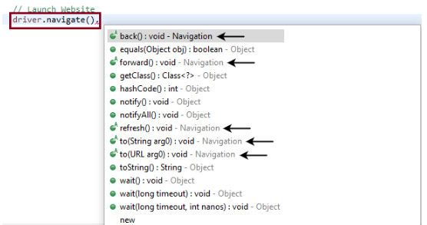



In WebDriver, the above mentioned method loads a new web page in the existing browser window.



In WebDriver, the above mentioned method enables the web browser to click on the **forward** button in the existing browser window. It neither accepts anything nor returns anything. The respective command that takes you forward by one page on the browser's history



In WebDriver, the above mentioned method enables the web browser to click on the **back** button in the existing browser window. It neither accepts anything nor returns anything. The respective command that takes you back by one page on the browser's history



In WebDriver, this method refresh/reloads the current web page in the existing browser window. It neither accepts anything nor returns anything.